***95 Burntwood Lane, SW17 0AJ***

This well presented four bedroom maisonette is arranged over two floors and offers light and airy accommodation.

On the first floor, the property comprises a reception room with sash windows allowing plenty of light and original fireplace feature, three bedrooms - two doubles and one single, a three-piece family bathroom and large kitchen/breakfast room with external staircase to a sunny private rear garden

To the second floor is a very large double aspect bedroom with en-suite shower room.

Garratt Lane is close by which provides numerous shops, restaurants

**£795,000**

Wandsworth Council Tax - Band D

***95 Burntwood Lane, SW17 0AJ***

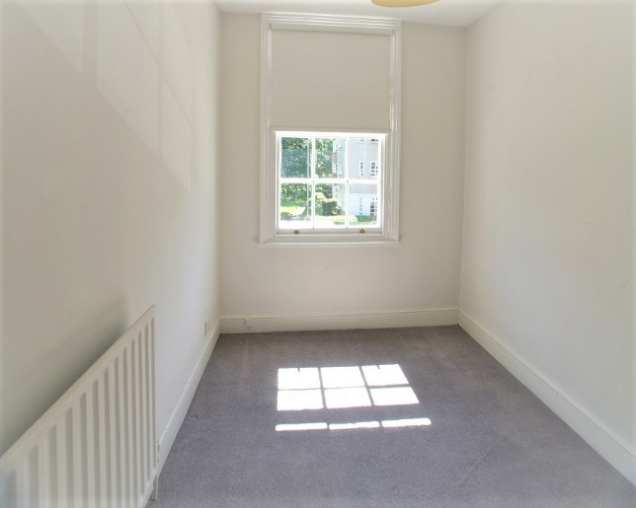

***95 Burntwood Lane, SW17 0AJ***



***95 Burntwood Lane, SW17 0AJ***

